Research

General overview and explanation

National Standard

There is a national standard for labels on wine, the particulars are prescribed by Regulations of the Liquor Products Act, the Wine of Origin Scheme and the Scheme for Estate Brandy.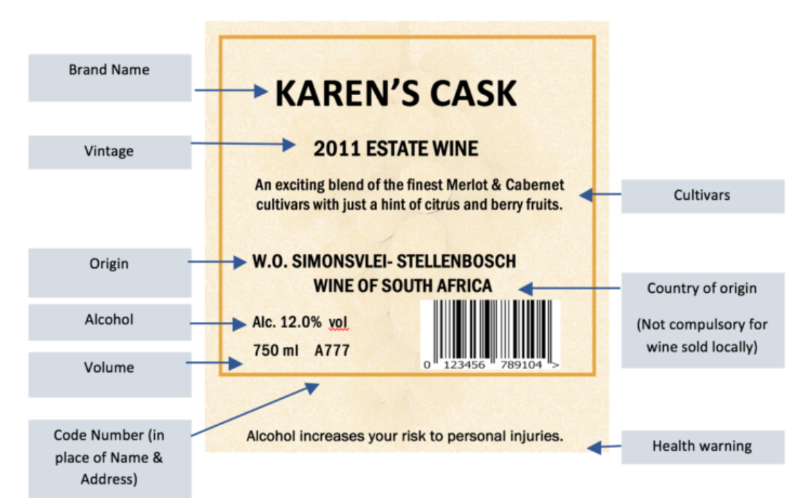

Wine types or categories

Two ways of classifying wine: By variety (Cultivar) or by region.

1. White Wines:Sauvignon Blanc, Chardonnay, Chenin Blanc, Colombard
2. Red Wines:Cabernet Sauvignon, Shiraz, Merlot, Pinotage

A more general classification, is diving wines into 9 general categories (Bodies of wine):

Full-Bodied Red Wines, Medium-Bodied Red Wines, Light-Bodied Red Wines, Rosé Wines ,Full-Bodied White Wines, Light-Bodied White Wines, Aromatic White Wines, Dessert Fortified Wines, Champagne & Sparkling Wines

| Wine Type | Taste | Color | Grapes | Fermentation and making process | Food pairings |
| --- | --- | --- | --- | --- | --- |
| Red Wine | Bitter, bold and rich. | Red | Black/dark coloured grapes. | Fermented with skins. | red meats and hearty dishes |
| White Wine | Fruity, sweeter than red, refreshing. | White | light-colored grapes | Grape skins removed before fermentation. | seafood, poultry, and lighter dishes |
| Rose Wine | Sweet/sometimes dry | Pink/Blush | Red or black grapes. | Skins are left in contact with the juice for a short period | salads, grilled vegetables, and seafood |
| Sparkling Wine | Fruity | White/ rose (usually) | black and white grapes | Effervescence, achieved through a secondary fermentation process | appetizers, seafood, and desserts |
| Dessert Wine | Sweet | Multiple colours | variety of grapes | Lower alcohol content | desserts, cheeses, and foie gras |

Points and Pricing wine

Oak, time and terroir.

* +$1 per year for ageing. +$2-4 in cost per bottle for oak.
* Expensive wines are aged in oak. This adds oak ‘flavours’ to a wine and exposes the wine to oxygen, this makes the tannins less intense, the wine becomes “smoother”.
* Time changes the taste of the fruit flavours in a wine. The longer a wine ages the less acidic it will become. Generally has “fruitier” flavours due to reduced acidity.

Terroir is the “region” of the wine, generally the more specific the region the more expensive the wine.

Wine is typically scored on a 100-point scale.

95-100 | Classic.

* 90-94 | Outstanding.
* 85-89 | Very good: a wine with unique qualities
* 80-84 | Good: a well-made wine
* 75-79 | Mediocre: a drinkable wine that may have minor flaws
* 50-74 | Not recommended

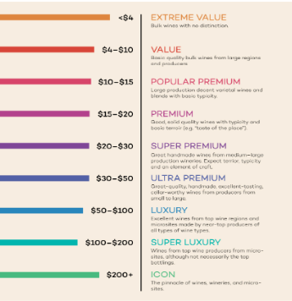

Other Useful Information

1. Best Time to Visit: January to March.

2. Wine Routes: Stellenbosch Wine Route, Franschhoek Wine Valley, Constantia Wine Route, and Hemel-en-Aarde Wine Route. These routes feature numerous wineries, tasting rooms, and attractions.

3. Cellar Door Sales: Many wineries offer cellar door sales, allowing visitors to purchase their favorite wines directly from the source. Take advantage of this opportunity to buy wines that may not be widely available elsewhere.

4. Wine Festivals and Events: South Africa hosts various wine-related festivals and events throughout the year. Stellenbosch Wine Festival, Franschhoek Bastille Festival, or Hermanus Wine and Food Festival.

References

Hammack, Justin. “The Truth About Cheap vs. Expensive Wine.” *Wine Folly*, https://winefolly.com/tips/truth-cheap-vs-expensive-wine/. Accessed 13 May 2023.

Packwood Country Estate. “An introduction to What is a Cultivar.” *Packwood Wine Estate*, 15 September 2020, https://www.packwood.co.za/latest-news/cultivars/. Accessed 13 May 2023.

Puckette, Madeline. “Wines Listed from Dry to Sweet (Charts).” *Wine Folly*, https://winefolly.com/tips/wines-listed-dry-sweet/. Accessed 13 May 2023.

SA Wine Industry Information and Systems (SAWIS). “LABELLING REQUIREMENTS FOR SOUTH AFRICAN WINE.” *LABELLING REQUIREMENTS FOR SOUTH AFRICAN WINE*, 2013, https://www.sawis.co.za/winelaw/download/LABELLING_REQUIREMENTS_FOR_SOUTH_AFRICAN_WINE_2013.pdf. Accessed 13 May 2023.

ownload/LABELLING_REQUIREMENTS_FOR_SOUTH_AFRICAN_WINE_2013.pdf. Accessed 13 May 2023.

https://www.stettyncellar.co.za/blog/south-african-wine-types/

https://www.thewinesociety.com/discover/explore/regional-guides/south-african-wine-ultimate-guide

https://www.wine-searcher.com/cheapest-sparkling-wine-in-south-africa

https://www.wine-searcher.com/regions-south+africa?tab_F=mostexpensive

Functional Requirements

* A user should be able to Register and Login.
* A user should be able to review a particular vineyard.
* A user should be able to create a favourite wine and vineyard list
* A user should be able to Receive wine tasting recommendations
* A users should be able to search for particular wines
* A user should be able to search for particular vineyards
* A user should be able to filter their wine searches by: sort by prices, names[A-Z] , filter by brand and category and price range.
* A vineyard should be able to advertise their vineyard on the website
  + Including: wine catalogue, wine routes, wine tastings

EER Diagram

WINE

Brand_name

Vintage (Date produced)

Origin

Volume

CodeNum

Caltivars

Category

Description

Price_Category

* 1. Cost per bottle
  2. Cost per glass

properties

* + 1. Sweetness(dryness)
    2. Acidity
    3. Tamin
    4. Alcohol concentration
    5. Body

Quantity

USERS

UID

(Name, surname, middle name)

Contact information: email, phone number

{Favourite wines}

{Favorite Vinjard}

Password

Region

Specialise: Tourists, Managers TOURISTS

BUSINESS

* 1. name

1. Contact details: email, number
2. Social medias: instagram, facebook,twitter
3. Website
4. Location
5. Description
6. Wine catalogue
7. Recommended wine
8. Specials
9. Reviews